**Density anomaly PV**

Bailey Avila, 01/03/2023

**Purpose:**

Using a run initialized with a density anomaly, we see the formation of VM and its signature in enstrophy and PV over time.

**Model setup:**

We analyze 1 run, initialized with zero flow and only a density anomaly in the center of the domain. This anomaly is gaussian in X, Y, and Z.

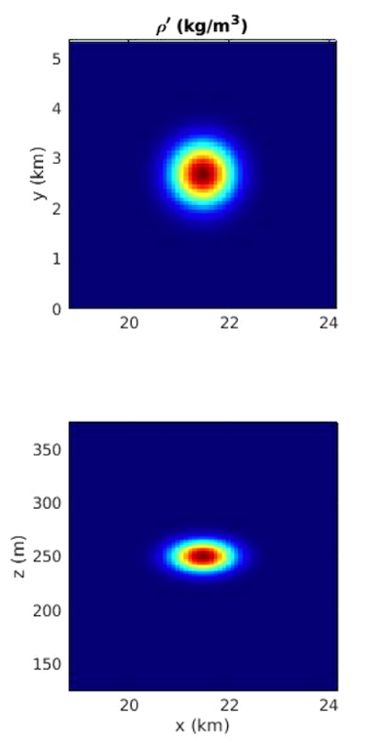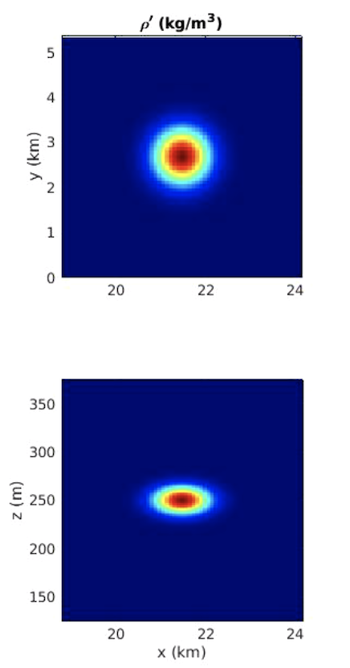

**Analyses:**

For each run, we compute the volume averaged enstrophy from both linear PV and APV, and then plot each value as a time series.

Additionally, we plot a histogram of linear PV (normalized by N^2f to be unitless), variance of linear PV (linear enstrophy) time series, a histogram of APV (normalized by f to be unitless), variance of APV (nonlinear enstrophy) time series. The histograms are plotted showing all time in the run, each successive time is plotted as a different color starting at blue and going to red. The mean value at each time is plotted as a dotted line in the same colors as the histogram; this is done as a sanity check that the mean of linear PV and APV vanish.

Lastly, each run is seeded with 100 particles and we track PV following the particles. Using the histogram, we can see if the PV change is significant.

**Equations:**

APV =

= (1/s)

LinearPV = (1/s3)

Nonlinear enstrophy = (1/s2)

Linear enstrophy = (1/s6)

**Results:**

From previous literature, we know VM can be generated in a linear run, however, from density anomalies adjusting geostrophically. So how does this reconcile? Do we see APV changes in adjusting density anomalies? Since we know VM is generated during the geostrophic adjustment of a mixed patch, that is where we start.

Figure 1: linear enstrophy (left) and nonlinear enstrophy (right) for run with single density anomaly adjusting geostrophically

Overall, we do see a spike in nonlinear enstrophy as expected when VM is generated, and we see nonzero linear enstrophy as we expect for linear VM. We can also look at particles inside the density anomaly, and outside the anomaly. We expect that we see modified PV inside the anomaly, and zero linear PV outside the anomaly.

a

b

Figure 2: linear (left) and available (right) PV over time following particles. Particle locations are: a) in the middle of the anomaly, b) away from the anomaly

In figure 2a, in the middle of the anomaly, we see the modification of linear PV and APV, consistent with VM generation. Figure 2b, the farthest particle away from the anomaly, is shows noise, with a small order of magnitude in comparison, so we can say there is no VM here. Since this is a linear run, APV may not be a useful quantity and is not necessarily conserved.

Similar to the enstrophy plots which are decreasing, we see a constant decrease in energy in the wave and vortex fields, figure 3. Initially there is an increase in wave energy, likely due to the fact that we start with no motion before the anomaly adjusts.

Figure 3: Energy over time separated into wave (top) and vortex (bottom). *Note: particle data was not written as long as data was output, so there are more time points here than in previous plots.

I am currently running a nonlinear density anomaly evolution to have a case where the linear PV and APV should be comparable. Since this was a linear run, the APV may not be a useful quantity, and may not be conserved since it is nonlinear in nature. In a nonlinear run, where linear PV and APV diverge should show where things fail.

Top: Density anomaly (initial condition) with particle locations

Bottom: linear PV over time for each particle

06

16

26

36

46

56

66

76

86

96

06 16 26 36 46 56 66 76 86 96

Blown up linear PV vs time plots

36 46 56

06 16 26

86 96

66 76